**Assignment 4**

*Team* **ThermoBank**

**Group members and tasks:**

*Viktoriya Rasuli –* wireframing and storyboarding

*Daryna Aloff –* navigational flow

*Kareem L. Hinton –* interaction flow

*Nikki A. Pham –* persona and annotations for wireframing

**Introduction**

In order to ensure safe travels with various commodities that are convenient to the user, we have developed a wrist mounted device called a ThermoBank. Its key feature is that it is heat charged and has the ability to charge any cellular or electronic device through that body heat alone, eliminating the need to carry around chargers or clunky wires. In addition to its charging capabilities, it comes preinstalled with our exclusive app that gives the user various features that they can benefit from, like tutorials for traveling, a built-in GPS to track yourself, and park information depending on your location. This multi-use ThermoBank allows users to lighten their loads when traveling so they can carry only the essentials on any trip without having to burden themselves with extra equipment that may not be used in any way during their trip.

**Wireframes**

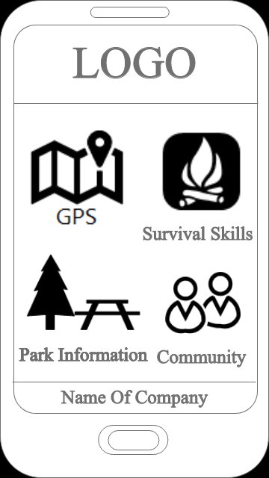**Page Description:**

This is the main page of our app.

It provides the user access to the GPS, Community,

Park Information and Survival Skills.

**User Action:**

User have to enter to the app.

**Business Rules:**  
Display a default logo at the top and the name of company at the

bottom.

User have ability to view all icons-buttons on the screen.

User can access only one icons-buttons at time.

To exit app user, have to click the button on the phone.

**Potential Enhancements/Changes/Issues:**

Provide to the user ability to login into device.

**Main Page Summary:** The presented page shows the main page

of app that includes four icons-buttons that will provides different pages with interaction to the user.

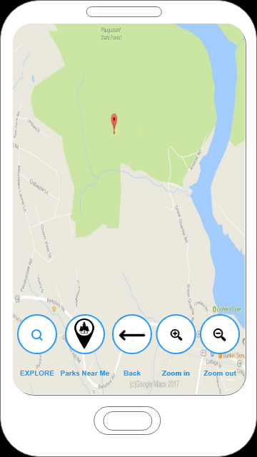**Page Description:**

This is the GPS. Here user can see map, zoom in/out buttons, back button, search button and button with picture of location sign with a tree inside.

**User Action:**

User have to enter to the app and choose GPS.

**Business Rules:**

All buttons are locating by default at the bottom.

Only one bottom works at one time.

Search window is hidden as long as user didn’t click Explore button.

**Potential Enhancements/Changes/Issues:**

Provide an exit button.

**Possible error state:**

If user trying to connect GPS without turning on Internet. The

Error message will appear that says: “No internet connection.”

**GPS Page Summary:**

To find path in park user have to click at the Explore bottom.

To find parks that near user location, user have to click on the

Bottom Parks Near me.

To return user have to click at the error.

To return on the main page user have to click at the return button at the phone.

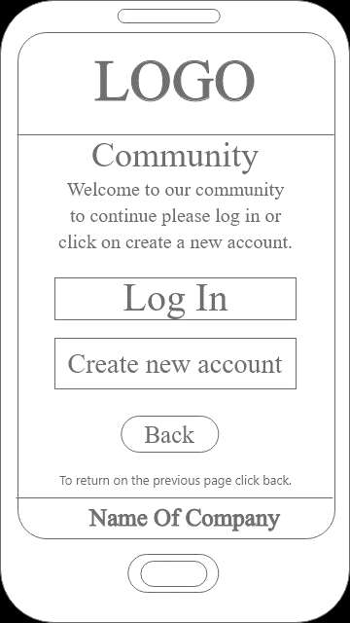**Description:**

This is the Community Main Page. Here user can Login into their personal account or create a new account.

**User Action:**

User have to enter to the app and choose Community.

**Business Rules:**

All buttons are locating by default at the bottom.

Only one bottom works at one time.

Search window is hidden as long as user didn’t

click Explore button.

**Possible error state:**

If user trying to connect Community without turning on Internet. The Error message will appear that says: “No internet connection.”

**Potential Enhancements/Changes/Issues:**

Provide an exit button.

**Page Summary:**

User has the option of logging into their account or creating a new account or backing out back to the app main menu.

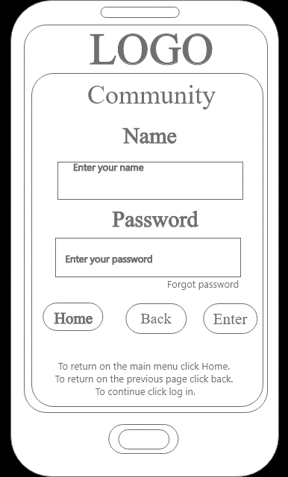

**Page Description:**

This is the Login page. Here user can login to their personal account or request a password change if they cannot remember their current password.

**User Action:**

User have to enter to the app and choose Community and then Login.

**Business Rules:**

All buttons are locating by default at the bottom.

Only one bottom works at one time.

**Possible error state:**

If user trying to type password longer than 6 character the error message will appear that says: “Wrong password or user name.”

**Potential Enhancements/Changes/Issues:**

Provide an exit button.

**Log In Page Summary:**

To go back to the Community Main Page, press the Back button to proceed back to the Community Main Page.

To return to the main menu, press the Home button to cancel any actions on the page and return to the main menu.

After inputting username and password, press Enter and if the information is valid, then user is accepted and proceeds to the Community Homepage.

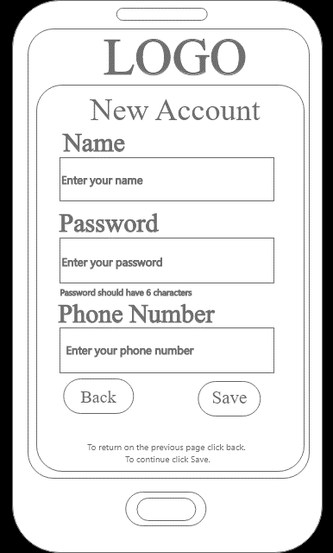

**Page Description:**

This is the New Account page. Here user can create a personal account to use the Community function

**User Action:**

User have to enter to the app and choose Community and then Create New Account.

**Business Rules:**

All buttons are locating by default at the bottom.

Only one bottom works at one time.

**Possible error state:**

If user trying to type password longer than 6 character the error message will appear that says: “Wrong password or user name.”

If user trying to use name that was used the error message will appear that says: “Sorry, that name in the use. Put different name.”

If user trying to type letters not numbers in the Phone Number, the error message will appear that says: “Please type only numbers in Phone Number window.”

**Potential Enhancements/Changes/Issues:**

Have a Check feature to make sure the phone number used isn’t already in the database.

Provide an exit button to the main menu.

**New Account Page Summary:**

To go back to the Community Main Page, press the Back button to proceed back to the Community Main Page.

To return to the main menu, press the Home button to cancel any actions on the page and return to the main menu.

After inputting username and password, press Enter and if the information is valid, then user is accepted and proceeds to the splash screen to return to the login page.

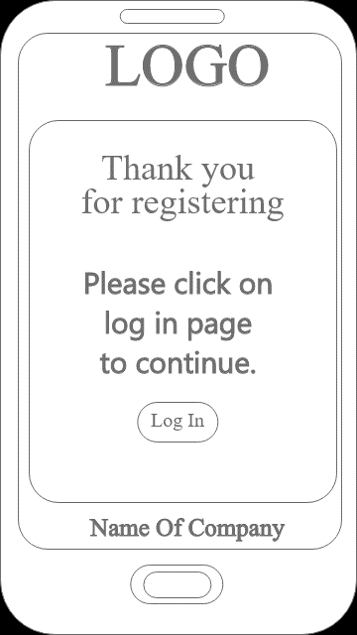

**Page Description:**

This is the Create New Account splash page. Here user is verified and is now able to login into the community by pressing the login button to move to the login page

**User Action:**

User have to enter to the app and choose Community and then Create New Account and successfully create an account and save it.

**Business Rules:**

All buttons are locating by default at the bottom.

Only one bottom works at one time.

**Potential Enhancements/Changes/Issues:**

Provide an exit button in case the user does not wish to continue to the login screen immediately.

**Thank You Page Summary:**

After inputting username, phonenumber and password and press Enter and if the information is valid, then user is moved to the splash screen and proceeds to the Login page.

**Page Description:**

This is the Community page. Here user can enter a group chat with other people they have linked up with and can upload/take pictures and post them on their pictures page.

**User Action:**

User have to enter to the app and choose Community and then Login successfully to reach the Community Main Menu.

**Business Rules:**

All buttons are split between left and right with the menu buttons above.

Only one bottom works at one time.

**Potential Enhancements/Changes/Issues:**

Move the exit button towards the bottom to keep with app default button layout.

**Community Page Summary:**

To go to the Community Main Menu, login into your personal account and confirm your login.

After inputting username and password, press Enter and if the information is valid, then user is accepted and proceeds to the Community Main Menu.

Exit will log out user and bring to the main page.

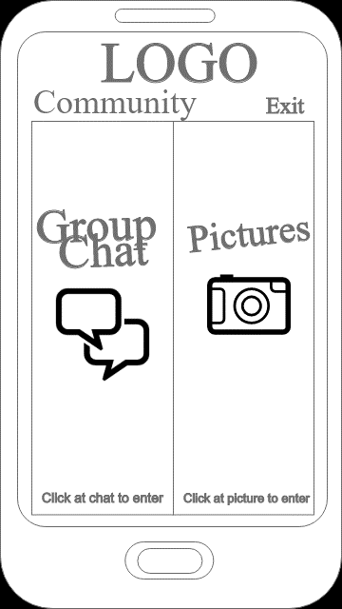

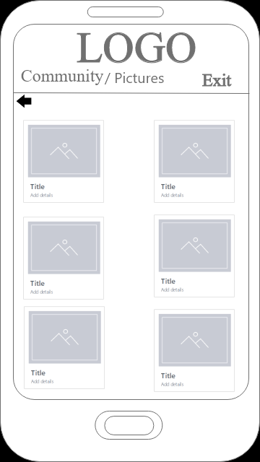

**Page Description:**

This is the Pictures page. Here user can view/upload/take/delete/share photos at their leisure to their personal accounts

**User Action:**

User have to enter to the app and choose Community and then Login and after successfully logging in, go to the pictures.

**Business Rules:**

All pictures are sorted in a 2-column feature.

Select a picture and it zooms in and allows user to share/etc. the pictures selected.

User can view one picture at the time.

User log outs when user click at exit and appears on the login page.

**Potential Enhancements/Changes/Issues:**

Move the exit button towards the bottom to keep with app default button layout.

**Pictures Page Summary:**

Pictures are displayed to the user.

User can manipulate the pictures to whatever they want to do.

When user is finished in this section, press the exit button to log out from community.

Press back button to return to the Previous page.

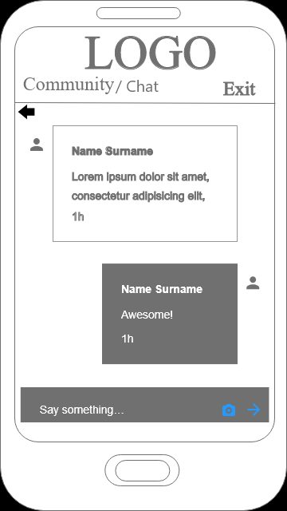

**Page Description:**

This is the Group chat page. Here user can chat with other users.

**User Action:**

User have to enter to the app and choose Community and then Login and after successfully logging in, go to the group chat button.

**Business Rules:**

Chats will be sorted by most recent group on top.

Chat is closing when a user clicks at the back button.

User log outs when user click at exit and appears on the login page.

**Possible error state:**

If user writes message longer then 25 words the error message is going to appear that says : “Your message is too long please break it down.”

**Potential Enhancements/Changes/Issues:**

Move the exit button towards the bottom to keep with app default button layout.

**Chat Summary:**

Group chats are displayed to the user.

User can chat with groups whenever they want

When user is finished in one group chat, use the back button to return to the group chats menu.

When user is finished in this section, press the exit button to log out from community.

Press back button to return to the Previous page.

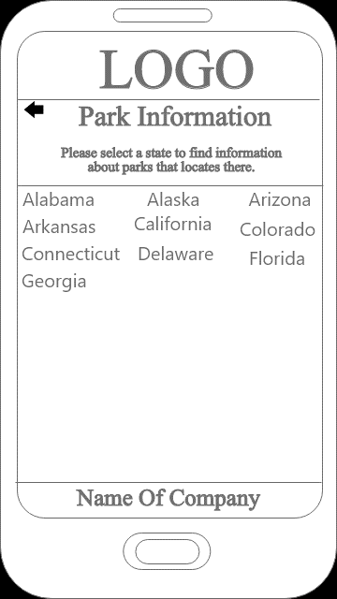

**Page Description:**

This is the Parks Information Main Menu page. Here user can select which state to view their respective parks. When user is finished in this part of the menu, the back button will return user to the App Main Menu.

**User Action:**

User have to enter to the app and choose Park Information button.

**Business Rules:**

All states are sorted in a 3-column feature.

Select a state and it opens to feature the parks in that state

Only one state button works at one time.

**Potential Enhancements/Changes/Issues:**

Move the exit button towards the bottom to keep with app default button layout.

Have the user type in the state name as another option.

**Park Information Page Summary:**

States are displayed to the user to select

The selected state will then list their parks for the user

When user is finished in this section, press the exit button to return to the App Main Menu.

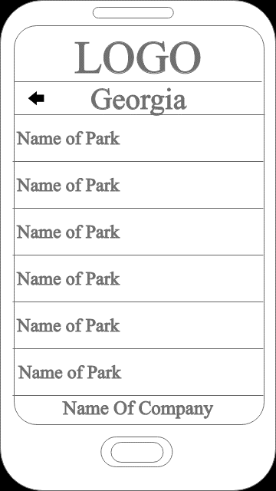

**Page Description:**

This is the state parks page. Here user can select the various parks in that state to view their information

**User Action:**

User have to enter to the app and choose Park Information and then select a state to view.

**Business Rules:**

All parks are sorted in a scroll list.

Select a park and it zooms in and allows user to see a picture and display information on that park.

Only one button works at one time.

Use the back button to return to the park list.

**Potential Enhancements/Changes/Issues:**

Move the exit button towards the bottom to keep with app default button layout.

**Georgia Page Summary:**

Lists the parks within that selected state.

After selecting a park, it allows user to view information on that park.

When user is finished in the park info screen, use the back button to return to the state park page.

When user is finished in that state page, use the back button to return to the Parks Information Main Menu.

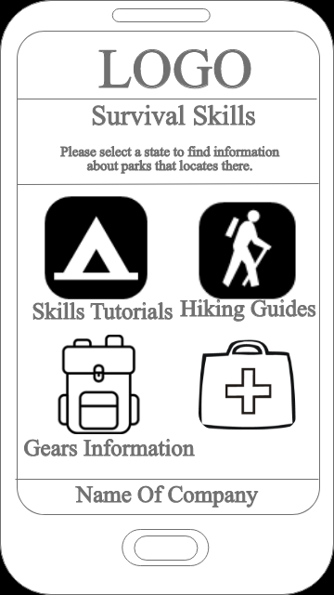

**Page Description:**

This is the Survival Skills page. Here user has access to various tools to aid in their travels like guides, tutorials, and gear information.

**User Action:**

User have to enter to the app and choose the Survival Skills button

**Business Rules:**

All options are sorted in a 4-block system.

Select an option and it zooms in and allows user to enter that page.

Only one button works at one time.

**Potential Enhancements/Changes/Issues:**

Move the exit button towards the bottom to keep with app default button layout.

**Main Page of Survival Skills Summary:**

Lists 4 options that user can select to get in-depth information on various topics for the user.

Each topic is unique in what they contain.

When finished, user can press the back button to return to the App Main Menu.

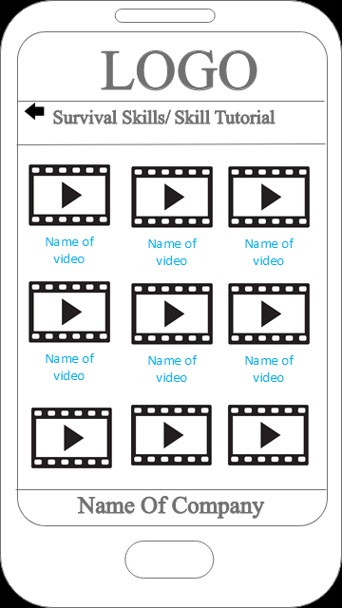

**Page Description:**

This is the Survival Skills - Tutorials page. Here user has access to various videos to aid in their travels like cooking, setting up camp, etc.

**User Action:**

User have to enter to the app and choose the Survival Skills button then press Skill Tutorials

**Business Rules:**

All videos are sorted in a list system.

Select an option and takes the user to YouTube so that they can view the video.

Only one button works at one time.

**Possible error state:**

If user trying to view video without turning on Internet. The Error message will appear that says: “No internet connection.”

**Potential Enhancements/Changes/Issues:**

Move the exit button towards the bottom to keep with app default button layout.

**Skill Tutorial Page Summary:**

Lists videos that user can select to get in-depth information on various tutorials for the user.

Each tutorial is unique in what they contain.

When finished, user can press the back button to return to the Survival Skills menu.

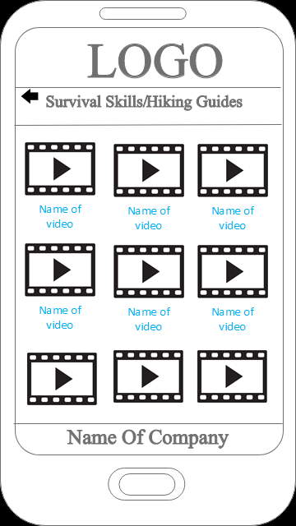

**Page Description:**

This is the Survival Skills – Hiking Guides page. Here user has access to various videos to aid in their travels like hiking tips, taking breaks, etc.

**User Action:**

User have to enter to the app and choose the Survival Skills button then press Hiking Guides

**Business Rules:**

All videos are sorted in a list system.

Select an option and takes the user to YouTube so that they can view the video.

Only one button works at one time.

**Possible error state:**

If user trying to view video without turning on Internet. The Error message will appear that says: “No internet connection.”

**Potential Enhancements/Changes/Issues:**

Move the exit button towards the bottom to keep with app default button layout.

**Hiking Guides Page Summary:**

Lists videos that user can select to get in-depth information on various guides for the user.

Each guide is unique in what they contain.

When finished, user can press the back button to return to the Survival Skills menu.

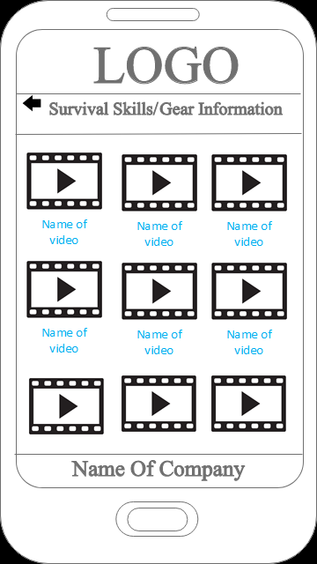

**Page Description:**

This is the Survival Skills – Gear Information page. Here user has access to various videos to go in-depth about various gears that they would need in order to travel correctly like camping bags, tents, materials for bags, etc.

**User Action:**

User have to enter to the app and choose the Survival Skills button then press Gear Information

**Business Rules:**

All videos are sorted in a list system.

Select an option and takes the user to YouTube so that they can view the video.

Only one button works at one time.

**Possible error state:**

If user trying to view video without turning on Internet. The Error message will appear that says: “No internet connection.”

**Potential Enhancements/Changes/Issues:**

Move the exit button towards the bottom to keep with app default button layout.

**Gear Information Page Summary:**

Lists videos that user can select to get in-depth information on various gears for the user.

Each gear info video is unique in what they contain.

When finished, user can press the back button to return to the Survival Skills menu.

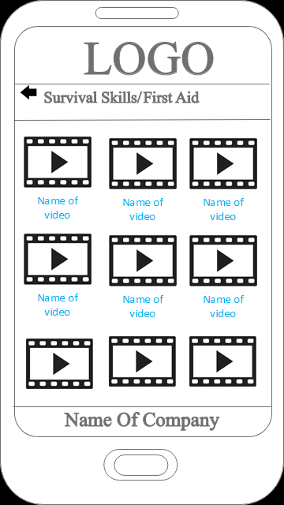

**Page Description:**

This is the Survival Skills – First Aid page. Here user has access to various videos to aid in their travels like patching up injuries, how to handle bear emergencies, etc.

**User Action:**

User have to enter to the app and choose the Survival Skills button then press First Aid

**Business Rules:**

All videos are sorted in a list system.

Select an option and takes the user to YouTube so that they can view the video.

Only one button works at one time.

**Possible error state:**

If user trying to view video without turning on Internet. The Error message will appear that says: “No internet connection.”

**Potential Enhancements/Changes/Issues:**

Move the exit button towards the bottom to keep with app default button layout.

**Main Page Summary:**

Lists videos that user can select to get in-depth information on various first aid guides for the user.

Each guide is unique in what they contain.

When finished, user can press the back button to return to the Survival Skills menu.

**Navigational flow**

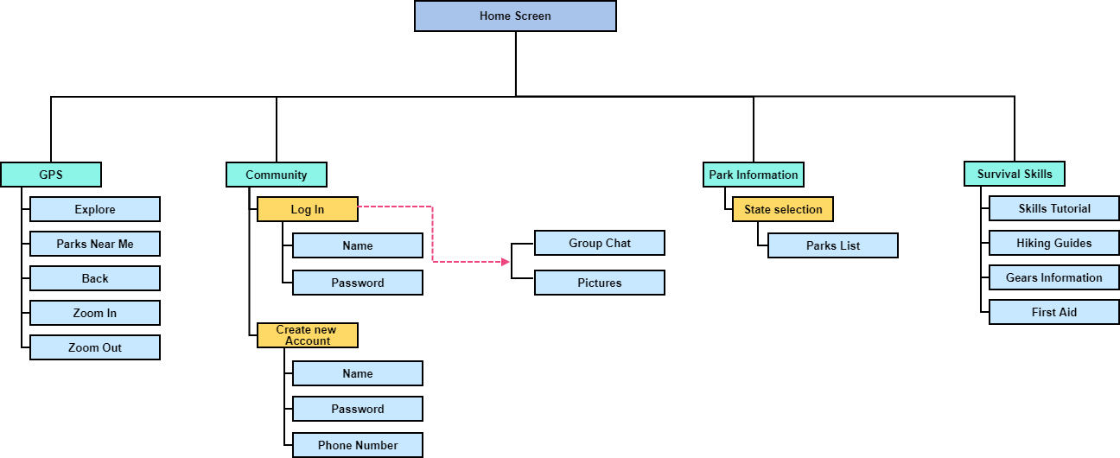

**Storyboard**

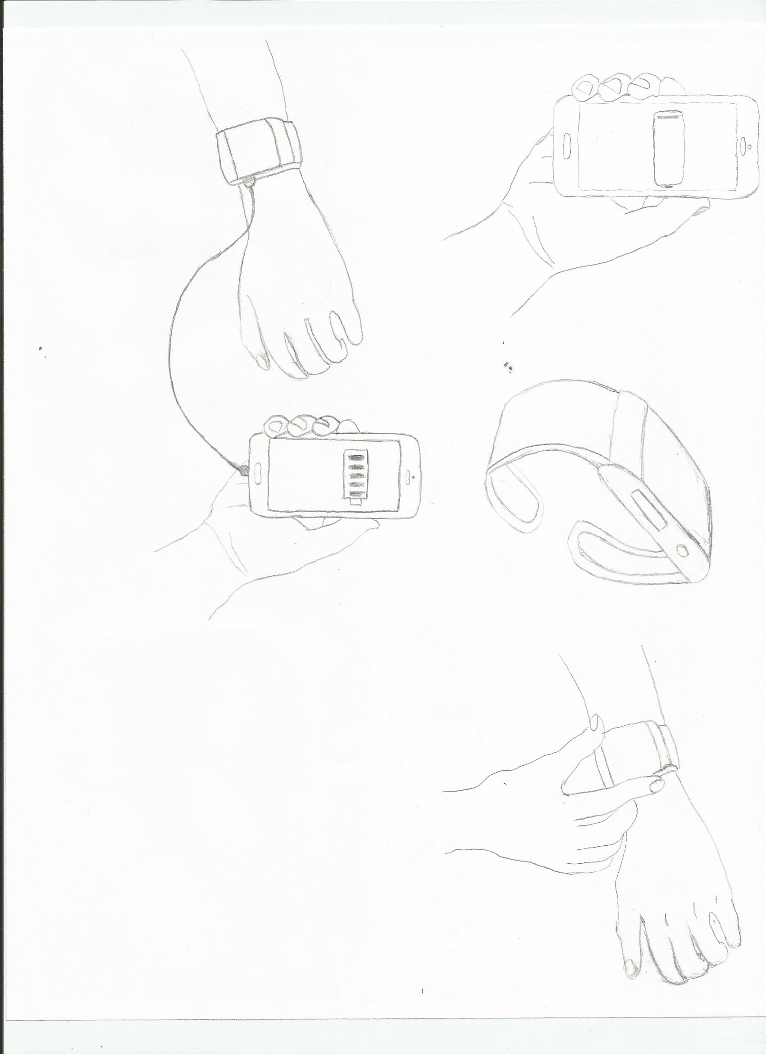

**Interaction Flow**



**GOALS:**

* Planning his most ambitious hike that will most likely take several days to successfully complete, but he doesn’t have a lot of info on the trail so any solution to give him more detailed information is wanted
* The hike he is partaking in will not have any electrical stations at the checkpoints
* Having only his phone as his navigational tool this time will be foolish, so he will carry a physical map to alleviate some battery use but will need to keep his phone charged in case of emergencies
* Since this is his longest hike, having a survival guide would be helpful in case something happens but doesn’t want to carry a large book if he doesn’t have to.
* Having only one spare battery in a Power Bank won’t be enough so he is looking for alternative solutions to charge his phone throughout the trip
* Doesn’t want to overburden himself with extra wires and cables that don’t need to be there if he doesn’t need it so alternative solutions to solve his cumbersome recharge tools are needed
* In case his phone runs out of battery, he is looking for solutions to help determine his location and the weather in case he gets lost or needs to reach a nearby checkpoint in a pinch
* Packing a lot of food for the trip but will need a way to help police what he is eating and how much of it so he can determine how far he can travel before his next meal

**SOLUTIONS:**

* In order to save space and require no extra set-up, the device will rest on the user’s wrist
* Our wrist device will be charged through body heat that requires no electrical charge in order to function
* The product does not require extra cables so users can attach their phone to the product and don’t have to worry about dangling wires interfering with daily life
* Our wearable device will feature many functions in its built-in app. Several functions include:
  + Ability to attach and charge phone on the wrist device and can allow user to check battery percent
  + Able to access weather and GPS information along with time information
  + Has access to an onboard Survival Guide that allows users to check on basic/advanced tips for camping/hiking and other information needed for any hiking problem
    - First Aid application
    - How to set up an effective camp
    - Various information on plants/animals relative to the trip user chose
  + Has ability to check up on various parks/trails/ranges and obtain detailed information on them
    - Degree of difficulty
    - Average hiking time
    - Total distance from start to finish
    - # of checkpoints
    - Average amount of other travelers
    - Recommended gear, time of day, and weather time to travel safely

**NAME:** Leon S. Kennedy

**RELATIVE DEMOGRAPHIC INFORMATION:**

* 34-year old hiker
* Spends his free time wandering local parks, mountain ranges, and any other lands he is permitted to travel through
* Typically travels alone but will go with groups for special occasions
* Usually depends on his smart phone to help navigation and determine the safety of each hike he commits to
* Carries a Power Bank to charge his phone in emergencies but usually forgets to charge it due to his forgetful nature.

